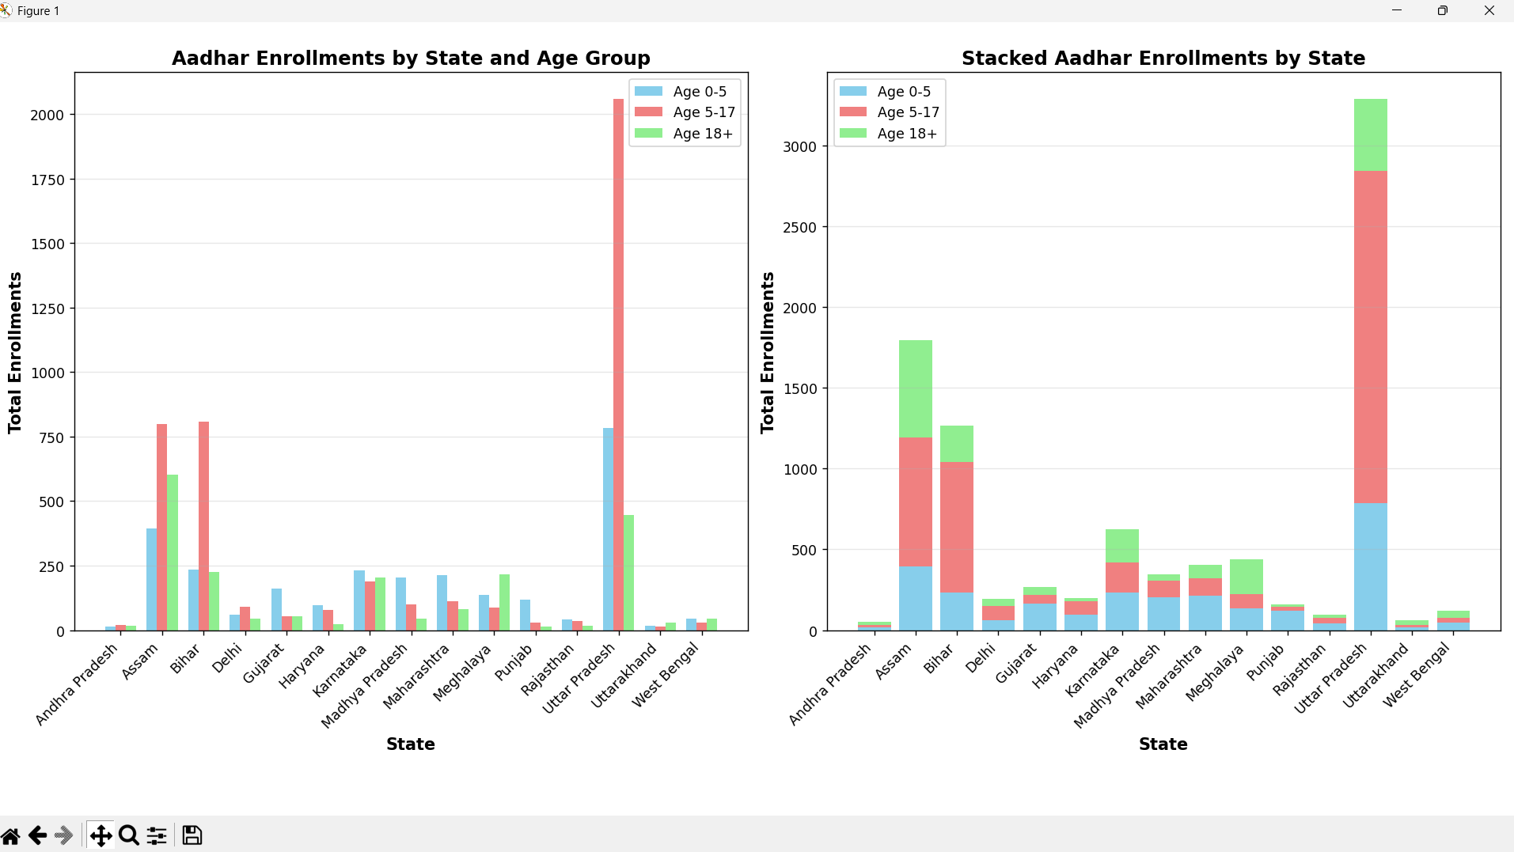

Chart’s Visualizations Created:
- Grouped Bar Chart (Left panel)
  - Compares enrollments across different states
  - Shows three age groups side-by-side for each state
  - Uses different colors: Age 0-5 (blue), Age 5-17 (coral), Age 18+ (green)
- Stacked Bar Chart (Right panel)
  - Shows total enrollments per state
  - Age groups stacked on top of each other
  - Gives a clear view of total enrollment volume per state
The bar charts are ideal for this dataset because they clearly compare categorical data (states/districts) with enrollment counts across different age groups, making it easy to identify patterns and regional differences in Aadhar enrollments.

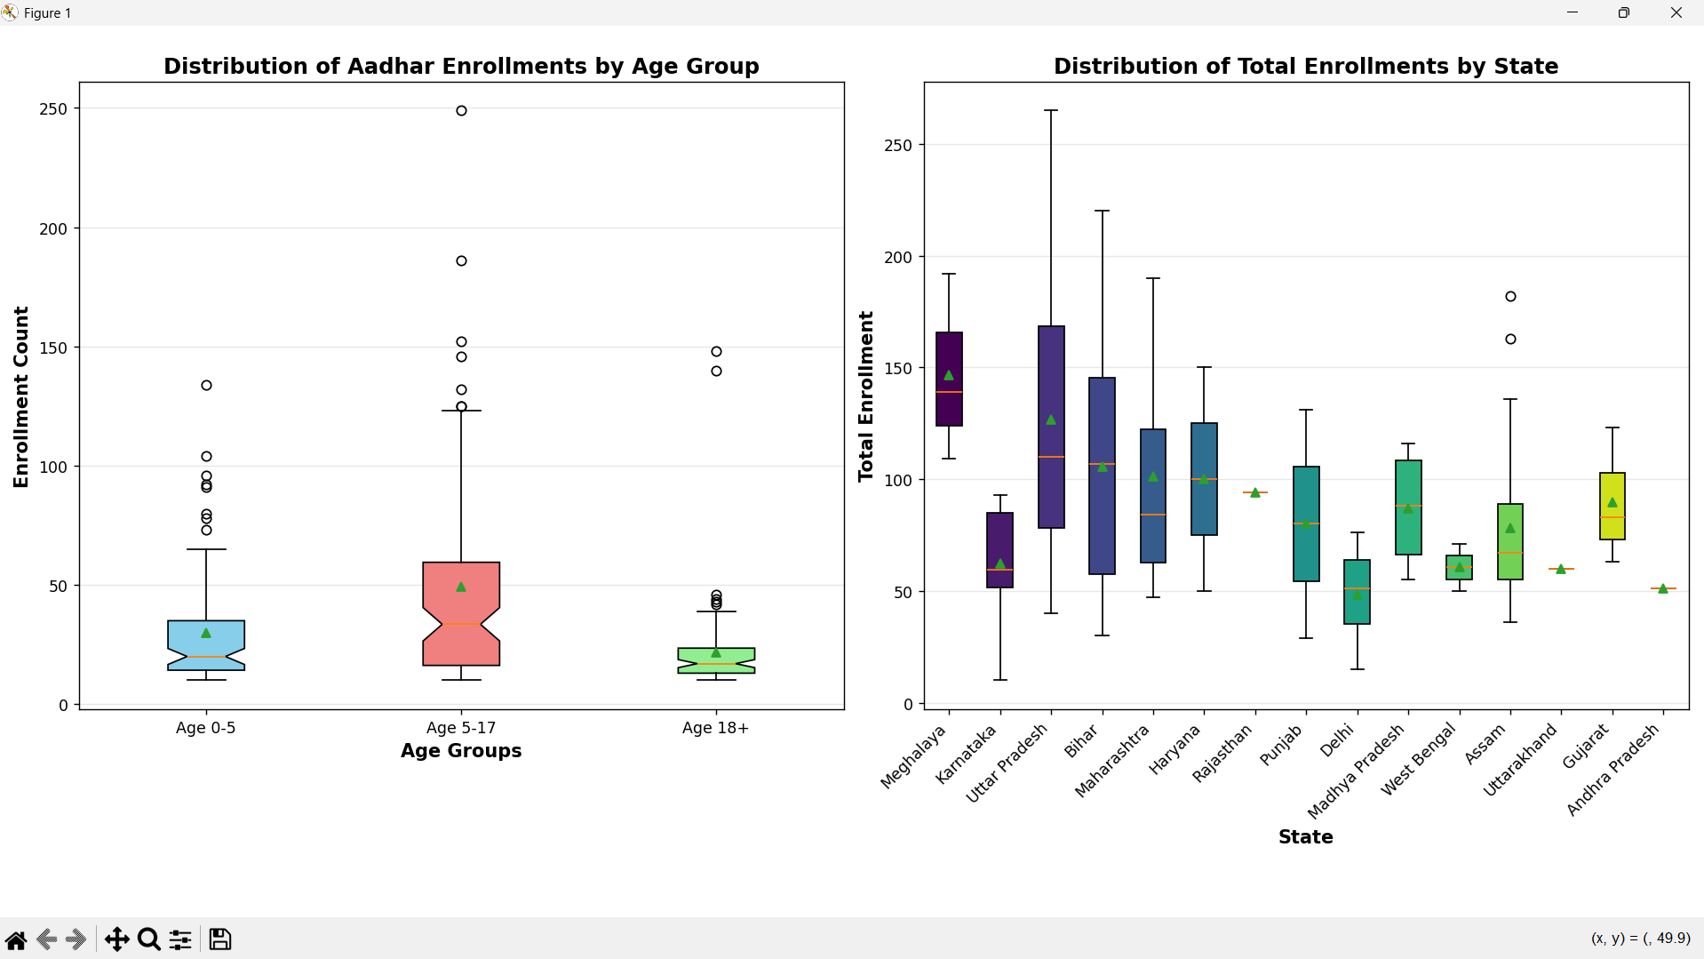

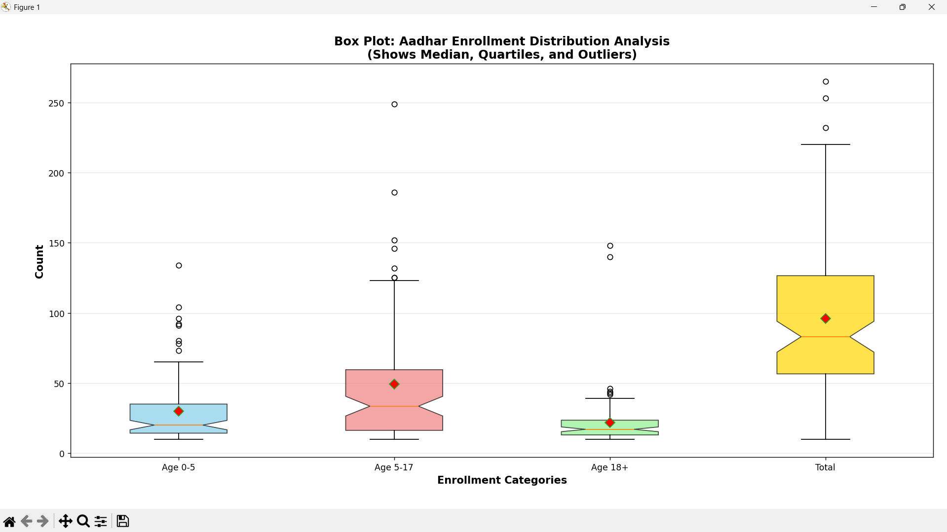

High Performing States
- Uttar Pradesh
Highest overall enrollment in both graphs
- Age 5–17 → Extremely high (largest among all states)
- Age 0–5 → Very high
- Age 18+ → Moderate but still large compared to many states
Uttar Pradesh is the top performing state with maximum Aadhaar enrollment, especially among school-age children.
- Assam
Second highest performer
- High enrollment in Age 5–17
- High enrollment in Age 18+
- Good enrollment in Age 0–5
Assam shows balanced and strong performance across all age groups.

Equal Performing States
These states show balanced but medium-level enrollments.
- Karnataka
- Almost equal enrollment in all age groups
- Moderate totals
Shows balanced Aadhaar awareness and participation.

Low Performing States
These states show lowest Aadhaar enrollment totals.
- Andhra Pradesh
- Very low enrollments across all age groups
- Uttarakhand
- Low enrollment in all age groups
- Still falls in low performance group

Age Group Wise Performance Insight
Age 0–5 (Children)
- Highest → Uttar Pradesh
- Good → Assam, Bihar
- Lowest → Andhra Pradesh, Jharkhand

Age 5–17 (School Age)
- Highest → Uttar Pradesh (dominates strongly)
- Second → Assam & Bihar
- Lowest → Andhra Pradesh, Gujarat

Age 18+
- Highest → Assam
- Moderate → Uttar Pradesh
- Lowest → Andhra Pradesh, Jharkhand

TOP 10 Districts by Total Aadhar Enrollment
